Reliable Power system stabilizers

H.M. Soliman¹ J.H. Taylor ² A.L. Elshafei¹ E.M.K. Makkawy¹

- Electrical Engineering Department, Faculty of Engineering, Cairo University, Cairo, Egypt.
2. Electrical & Computer Engineering Department, University of New Brunswick, Fredericton, NB, Canada E3B 5A3.

Abstract

This paper describes a simple method for the design of reliable decentralized stabilization using two controllers. Excitation and governor controllers are used to stabilize a synchronous machine infinite bus system. The goal is to maintain stability when both controllers act together and when either one of the two controllers fails (i.e., to achieve fault tolerant control).

1-Introduction

Power systems are subjected to low frequency oscillations due to disturbances. Such oscillations may sustain and grow to cause system separation if adequate damping is not available. To enhance system damping, generators are equipped with power system stabilizers (PSSs) that provide supplementary feedback stabilizing signals in the excitation channel.
Conventional PSSs are proposed in [1,2] that act by adding a phase lead controller to the system. Several approaches based on modern control theory have been applied to the PSS design problem. These include optimal control [3], intelligent control [4,5,6] and robust control [7].
Unfortunately, if an outage occurs in a PSS (excitation control), the synchronous machine (plant) loses stability. Motivated by the idea that “two controllers are better than one” for stabilizing a single plant, it has been found that governor control can be of great help. A control system designed to tolerate failures in system stabilizers while maintaining acceptable closed loop stability is called a reliable control system. In other words, the system should be stable when both excitation and governor controllers are acting together and in the case of the possible outage of either one of the controllers.
It should be pointed out that redundancy is the key ingredient in any reliable control system. It should also be noticed that the fundamental difference between traditional robust control and reliable control lies in the fact that the former mainly deals with medium size parameter variations or model uncertainties, while the latter treats more drastic changes in system configurations caused by outright component failures.
There are two methodologies for reliable control system design, factorization methods [8, 9, 10], and state space methods [11]. Even though reliable control systems are extremely important in practice, unfortunately, only a very limited number of papers are devoted to this subject in the literature.
In this paper a novel method is proposed to design reliable excitation and governor controllers for enhancing power system dynamic stability.

- Problem Formulation

Given a linear time invariant system,

$\overset{}{x}=\text{Ax}+\text{Bu}, y=\text{Cx}$ (1)

where x(t) $∈$ R^{n}, u(t) $∈$ R² and y(t) $∈$ R² represent the state, input and output vectors, respectively.
It is desired to stabilize the system in a decentralized manner, i.e., two controllers are used where each controller uses its local outputs only. The assumption of decentralization (independent sensor for each controller) is crucial so as to increase the chance that at least one of the controllers survives. Otherwise, in case of sensors’ failure, both controllers will be disabled and the system will break down. Accordingly, we decompose system (1) as follows:

$u=\left[\begin{matrix}u_{1} \\ u_{2}\end{matrix}\right], B=\left[\begin{matrix}B_{1} & \end{matrix}B_{2}\right], C=\left[\begin{matrix}C_{1} \\ C_{2}\end{matrix}\right]$ (2)

Thus system (1) will be treated as a two-channel linear system,

$\begin{aligned}\overset{}{x}=\text{Ax}+B_{1}u_{1}+B_{2}u_{2} \\ y_{1}=C_{1}x,y_{2}=C_{2}x\end{aligned}$ (3)

where $\text{uu}$ $u_{1}$and $u_{2}$ are two control inputs and $y_{1}$, $y_{2}$ are two measured outputs of the system. We assume that the triples (C_{1,} A, B₁) and (C₂, A, B₂) are both stabilizable and detectable. Therefore the system can be stabilized either from u₁ using y₁ only or from u₂ using $y_{2}$ only (decentralized control).
From (3), we obtain the transfer matrix of the system as
$\left[\begin{matrix}Y_{1}(s) \\ Y_{2}(s)\end{matrix}\right]=\left[\begin{matrix}G_{\text{11}}(s) & G_{\text{12}}(s) \\ G_{\text{21}}(s) & G_{\text{22}}(s)\end{matrix}\right]\left[\begin{matrix}U_{1}(s) \\ U_{2}(s)\end{matrix}\right]$ (4)
where
$\begin{aligned}G_{\text{11}}(s)=C_{1}(\text{sI}−A)^{−1}B_{1},G_{\text{12}}(s)=C_{1}(\text{sI}−A)^{−1}B_{2} \\ G_{\text{21}}(s)=C_{2}(\text{sI}−A)^{−1}B_{1},G_{\text{22}}=C_{2}(\text{sI}−A)^{−1}B_{2}\end{aligned}$ (5)
We also use G(s) = [G_{i,j} (s) ], i,j = 1,2 to represent the transfer matrix of the overall system. Now we connect two dynamic output feedback controllers
$U_{1}(s)=R_{1}\left(s\right)−K_{1}(s)Y_{1}(s),U_{2}(s)=R_{2}\left(s\right)−K_{2}(s)Y_{2}(s)$ (6)
to the system. R₁ and R₂ are the reference signals for channels 1 and 2, respectively. For simplicity, we drop the argument s.
The block diagram of the closed loop decentralized control is as shown in Fig (1).

R₁
-
-
K₁
G
K₂
Y₁
Y₂
R₂

Fig. 1. Reliable decentralized controllers

Failures that occur in sensors (i.e., in matrices C₁, C₂) and/or actuators (matrices B₁ and B₂) are modeled in Fig (1) by replacing the transfer functions K₁ and/or K ₂ by zero.
Our goal is to find reliable controllers that maintain the stability of G with the two controllers acting together and also under the possible failure of either one of the two controllers. We summarize this objective as follows:
Problem: Given the system (3), described in transfer function form as in (4), find K₁ and K₂ such that:
(i) when K₁ is the only active controller, it stabilizes G.
(ii) K₂ stabilizes G when K₁ is either on (active) or off (failed).
Of course, we could have started with K₂ instead of K₁. Based on condition (i) and (ii), we may consider K₁ to be the main controller and K₂ to be a redundant (backup) controller.

3-Problem solution

- Design of K₁, when K₂ is off

We use the following lemma:

Lemma: When K₂ is off, K₁ stabilizes the overall system (3) if and only if it stabilizes the subsystem G_{11.}
Proof: when K₂ is off, we have
$\left[\begin{matrix}Y_{1} \\ Y_{2}\end{matrix}\right]=\left[\begin{matrix}G_{\text{11}} & G_{\text{12}} \\ G_{\text{21}} & G_{\text{22}}\end{matrix}\right] \left[\begin{matrix}R_{1} − K_{1} Y_{1} \\ R_{2}\end{matrix}\right]$ (7)

Designing K_{1 to} stabilize the subsystem G₁₁ via the feedback U₁= R₁ - K₁ Y₁ results in

$\left[\begin{matrix}1+K_{1}G_{\text{11}} & 0 \\ K_{1}G_{\text{11}} & 1\end{matrix}\right]\left[\begin{matrix}Y_{1} \\ Y_{2}\end{matrix}\right]=\left[\begin{matrix}G_{\text{11}} & G_{\text{12}} \\ G_{\text{21}} & G_{\text{22}}\end{matrix}\right]\left[\begin{matrix}R_{1} \\ R_{2}\end{matrix}\right]$ (8)

Solving (8) for Y, we obtain

$Y=\left[\begin{matrix}Y_{1} \\ Y_{2}\end{matrix}\right]=\left[\begin{matrix}G'_{\text{11}} & G'_{\text{12}} \\ G'_{\text{21}} & G'_{\text{22}}\end{matrix}\right] \left[\begin{matrix}R_{1} \\ R_{2}\end{matrix}\right] \underline{\underline{Δ}} G^{'} R$ (9)

where
$\begin{matrix}G_{\text{11}}^{'} & & {G_{\text{11}}}/{d^{'}} & \\ G_{\text{12}}^{'} & & {G_{\text{12}}}/{d^{'}} & \\ G_{\text{21}}^{'} & & {G_{\text{21}}}/{d^{'}} & \\ G_{\text{22}}^{'} & & {\left\{K_{1}\left(G_{\text{11}}G_{\text{22}}−G_{\text{12}}G_{\text{21}}\right)+G_{\text{22}}\right\}}/{d^{'}} & \\ & & & \end{matrix}$ (10)
$\begin{matrix}\begin{matrix}d^{'} & & 1+K_{1}G_{\text{11}}\end{matrix} & \end{matrix}$ (11)

The form of d′(s) proves the result Q.E.D.

- Design of K₂

This controller K₂ must stabilize the overall system G when K₁ is either on or off. It is easy to show that the characteristic equation of the system is $\left(1+K_{1}G_{\text{11}}\right) \left(1+G_{\text{22}}^{'}K_{2}\right) =0\text{.}$
Hence, we conclude the following two cases.
• Case 1: K₁ is off – As before, K₂ stabilizes the overall system G if and only if it stabilizes the subsystem G_{22.}
• Case 2: K₁ is on – In this case we observe that the system seen by K₂ is given by Y = G'R (9). Thus the controller $K_{2}$stabilizes (9) if and only if it stabilizes$G_{\text{22}}^{'}$. So, $K_{2}$ must stabilize both $G_{\text{22}}$ and $G_{\text{22}}^{'}$ simultaneously. In other words, the reliable stabilization problem is reduced to a simultaneously stabilization problem [12, 13]. It will be shown that using MATLAB, the root locus technique can be used to accomplish the required design. The proposed algorithm is illustrated using a single-machine infinite-bus model of a power system.

4. Reliable Stabilization of a Single Machine Infinite Bus Model

The objective is to design reliable decentralized excitation and governor controllers to enhance the dynamic stability of a synchronous machine infinite bus model of a power system, Fig. 2.
Infinite
Bus
_
V_{ref}
K₁
_
Transmission Line
Trans.
Generator
AVR &
Exciter
V_{t}
U₁
T
Governor
_
K₂
_
U₂

Ex

Fig. 2. Schematic diagram of a single-machine infinite-bus system
Excitation & Governor supplementary control

The studied system is modeled as a fifth order system. A third order synchronous machine is represented by the state variable $Δδ$ (incremental torque angle), $Δω$(incremental angular velocity), $ΔE'_{q}$(incremental voltage proportional to q-axis flux linkage, behind transient reactance).In addition, a first order speed regulator is represented by the state variable ${ΔP}_{m}$(incremental mechanical power input), and a first order voltage regulator represented by the state variable ${ΔE}_{{}_{f}}$(incremental field voltage).
The dynamics of the studied system is described by [2, 14]
$\begin{matrix}\overset{˙}{x} & & \text{Ax}+\text{Bu} \\ y & & \text{Cx}\end{matrix}$ (12)
where
$\overset{∘}{x} =\begin{aligned}\left[ 0 ω_{0} 0 0 0 | \right]\left[−\frac{k_{1}}{M} 0 −\frac{k_{2}}{M} 0 \frac{1}{M} | \right]\left[−\frac{k_{4}}{T _{d0}} 0 −\frac{1}{k_{3}T _{d0}} \frac{1}{T _{d0}} 0 | \right]\left[−\frac{k_{5}k_{e}}{T_{e}} 0 −\frac{k_{6}k_{e}}{T_{e}} −\frac{1}{T_{e}} 0 | \right] \\ \end{aligned}$ (14)

$$y = \begin{aligned}\left[0 1 0 0 0 | \right] \\ \end{aligned}$$

where

$$x^{T}(t) = [Δδ Δω ΔE _{q} {ΔE}_{f} {ΔT}_{m}]$$
$$y^{T}(t) = [Δω Δδ]$$
and ω₀= 314

Remark 1: The above model neglects stator transients and the effects of damper bars. Had the effects of the latter been considered, it will result in more damping than that will be provided by the proposed design.

Remark 2: Selecting the main and back up controllers
Of course, we could have started the design with K₂ instead of K₁. Based on the condition (i) and (ii), we may consider K₁ to be the main controller and K₂ to be a redundant (backup) controller. In practice, exciter channel provides rapid control, so it is selected as the main controller. On the other hand, the governor channel provides slow control (due to its time delay), so it is selected as the back up controller.

Using the data in appendix, we get

$$\begin{matrix}A & & \end{matrix}$$

$$\begin{matrix}B & & \end{matrix}$$

$\begin{matrix}C & & \end{matrix}$

To stabilize the system in a decentralized manner, it is possible to decompose $B$ and $C$ as follows:
$\begin{matrix}B & & \left[B_{1 }B_{2}\right] & , & C & & \left[\begin{matrix}C_{1} \\ \\ C_{2}\end{matrix}\right]\end{matrix}$.
It is easy to check that the triples $\left(C_{1},A,B_{1}\right)$ and $\left(C_{2},A,B_{2}\right)$ are controllable and observable. The transfer matrix of this system is

$\begin{matrix}\left[\begin{matrix}G_{\text{11}} & G_{\text{12}} \\ G_{\text{21}} & G_{\text{22}}\end{matrix}\right] & & \frac{1}{d}\left[\begin{matrix}−\text{11}\text{.}\text{57}s(s+1) & 0\text{.}1s(s+2\text{.}\text{04})(s+\text{18}\text{.}\text{43}) \\ −\text{3634}\text{.}\text{05}(s+1) & \text{31}\text{.}4(s+\text{18}\text{.}\text{43})(s+2\text{.}\text{04})\end{matrix}\right]\end{matrix}$ (13)

where $d=(s+\text{18}\text{.}\text{27})(s+3\text{.}\text{217})(s+0\text{.}\text{971})(s^{2}−0\text{.}\text{993}s+\text{30}\text{.}\text{57})$ .It is to be noticed that the open-loop system is unstable. We follow the process in Section 3, starting with the first loop (K₁) then designing K₂ to solve the simultaneous stabilization problem, see Fig. 2.

a- Design of K₁ to stabilize G₁₁

Using the root locus technique, we design K₁ controller to stabilize G₁₁ (13), The controller transfer function is selected to be
. $K_{1}=−\text{530}\frac{(s^{2}+3\text{.}\text{52}s+\text{12}\text{.}\text{04})}{s(s+\text{50})}$
The added pole at -50 is selected to be nondominant (having slight effect on the dynamic response) .This achieves a realizable proper transfer function. The designed K₁ is nearly PID (Proportional Integral Derivative) control
$$K_{1}=−\text{530}(3\text{.}\text{52}+\frac{\text{12}\text{.}\text{04}}{s}+s)$$
widely used in industry.
b- Design of K₂ to stabilize G₂₂ and G`₂₂ simultaneously

We use the relations in (10). When K₁ fails, K₂ stabilizes the overall system if and only if it stabilizes G₂₂. Also, when K₁ is on, K₂ stabilizes the overall system if and only if it stabilizes G'₂₂. The transfer functions G₂₂ and G'₂₂ are given by
$$G_{\text{22}}= \frac{\text{31}\text{.}4(s+\text{18}\text{.}\text{43})(s+2\text{.}\text{04})}{(s+\text{18}\text{.}\text{27})(s+3\text{.}2)(s+0\text{.}\text{971})(s^{2}−0\text{.}\text{993}s+\text{30}\text{.}\text{57})}$$

$$G'_{\text{22}}= \frac{\text{31}\text{.}4(s+\text{50})(s+\text{18}\text{.}\text{43})(s+2\text{.}\text{04})}{(s+\text{53}\text{.}2)(s+0\text{.}\text{985})(s^{2}+\text{12}\text{.}\text{26}s+\text{57}\text{.}\text{27})(s^{2}+5\text{.}\text{01}s+\text{53}\text{.}\text{66})}$$

Once again, we use the root locus technique to design $K_{2}$ that simultaneously stabilizes G₂₂ and G'₂₂ . The resulting controller transfer function is
. $K_{2}=\text{65}\frac{(s^{2}+0\text{.}\text{486}s+5\text{.}\text{96})}{(s+\text{20})^{2}}$
It is to be noted that K₂ is a double lead controller.
The above controllers $K_{1}$ and $K_{2}$ achieve at least a degree of stability (0.98).
The impulse responses of the systems under reliable stabilization are shown in Figs. 3-5. As designed, the system can tolerate the outage of any of the two controllers without seriously deteriorating the degree of stability.
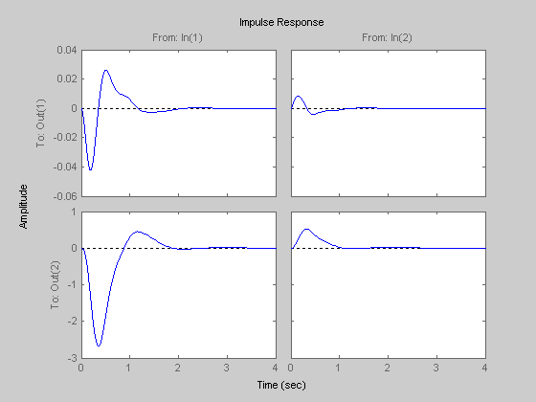
Fig. 3. Impulse responses when K₁ and K₂ are active (no failure).
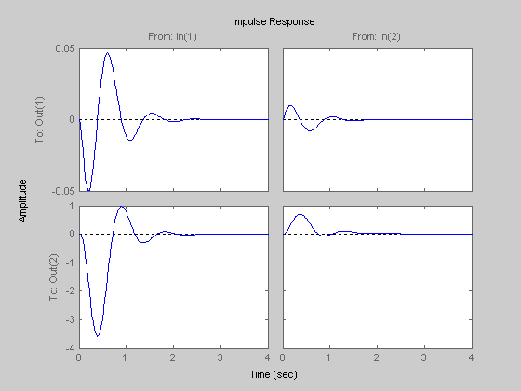
Fig. 4. Impulse responses when K₁ only is active (failure in K₂)
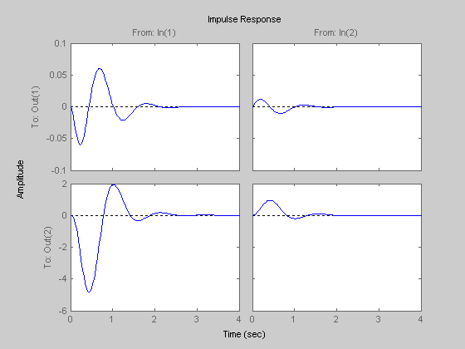
Fig. 5. Impulse responses when K₂ only is active (failure in K₁).

5- Robustness evaluation of designed stabilizers ٌ

To assess the effectiveness and robustness of the proposed stabilizers, three different loading conditions are selected as follows
_______________________________
Loading P (p.u) Q (p.u)
_______________________________
Nominal 1.2 0
Light 0.7 0.3
Heavy 1.2 0.4
______________________________

The reliable stabilizers give similar behavior as shown in Figures 3-5.
The above analysis shows the effectiveness and robustness of the proposed reliable stabilizers and their ability to provide good damping of low frequency oscillations under different loading conditions.

6- Conclusions

A new method has been developed for the design of a reliable excitation/governor control system. The algorithm is applied to a single-machine infinite-bus model. The two controllers retain the stability margin of the system when both controllers are operative and when either one of them fails.
References

1-P.Kundur”Power system stability and control” McGraw Hill, 1994
2-P.M.Anderson and A .A . Fouad "Power system control and stability "IEEE Press, J .Wiley, 2/e, 2003
3-Y.N.Yu”Electric power system dynamics” Academic Press, 1983
4-M.A.Abido and Y .L. Abdel Magid”Hybridized rule based power system stabilizers with genetic algorithms” IEEE Trans. Power system, vol. 14, pp600-7, 1999
5-N.Hosseinzadeh and A. Kalam “A direct adaptive fuzzy power system stabilizer” IEEE Trans. Energy Conversion, vol. 14, pp1564-71, 1999
6-P.Shamsollah and O .P .Malik ”An adaptive power system stabilizer using on line trained neural networks” ibid, vol. 12, pp382-7, 1997
7-H.M.Soliman, A .L .El Shafei, A .A .Shaltout and M .F .Morsi ”Robust power system stabilizer” IEE Proc. – Gen. Trans. Distrib., vol. 147, pp285-91, 2000
8-X.L Tan, D .D .Siljak and M .Ikeda “Reliable stabilization via factorization methods” IEEE Trans., vol. 37, pp1786-90, 1992
9-M.Vidyasagar and N. Viswanadham “Algebraic design techniques for reliable stabilization “IEEE Trans. AC, vol. 27, pp1085-95, 1982
10-A.N.Gundes “Reliable decentralized stabilization of linear systems” IEEE Trans, . AC, vol. 43, pp1733-9, 1998
11-R.J.Veillette”Reliable linear quadratic state feedback control” Automatica , vol. 31, pp 137-43, 1995
12-V.D.Blondel “Simultaneous stabilization of linear systems” Springer Verlag, 1994
13-B.K.Ghosh and X .A .Wang”Sufficient condition for generic simultaneous pole assignment and stabilization of linear MIMO dynamical systems” IEEE AC, vol. 45, pp734-8, 2000
14-H.M.Soliman and M .F .Sakr “Wide range power system pole placer” IEE Proc. , vol. 135 , Pt. C, pp195-201, 1988
Appendix
Studied system data (in p.u. , unless otherwise stated)
Machine constants $x_{d}=1\text{.}6,x_{q}=1\text{.}\text{55},x'_{d}=0\text{.}\text{32},x_{e}=0\text{.}4,r_{e}=0,T'_{\text{do}}=6\text{sec,}M=\text{10}$
Excitation system $k_{e}=\text{25},T_{e}=\text{.}\text{05}$sec
Governor system $T_{g}=1$sec
Speed regulation $R=1/{\text{20}}$
Loading P=1.2, Q=-0.5

